# **MIE 1622 Course Project: Robo Advisor**

**Pai Peng**

**Liyan Liu**

**Yiqi Fei**

**Beishi He**

**Zhengkun Chen**

**The demand**

Financial instability has continued to be an issue due to the endless pandemic and escalated international conflict. But this creates a window for benefiting from the recovery of economics as well. The two things combined have increased the demand for value investment, especially from people who have financial awareness. However, the high consulting price and management fee can be a barrier to people who seek advice from professionals for efficiently allocating their assets. And our development of the chat-robo for financial services in this project is set to tackle the problem.

**Our solution**

In contemporary society, Robo-advisors are widely used in the financial industry due to the emerging digitalization and technologies. Our Robo-advisors is designed as an online investment platform that provides automated and algorithm-driven investment services with minimal human oversight. The investors need to provide their own financial situation to the Robo-adviser, things like their investment total, cash preference, interested sectors and so on. Robo-advisors(backend) would find the ideal portfolio based on the client preference and real-time market prices. Then the portfolio will be delivered to the client with a comprehensive demonstration on performance and possible analysis.

There are many advantages of consulting our Robo-advisors. Firstly, though there is no determined price point at the moment, we expect that the service comes at a much lower cost than consulting real agents plus that you will have the freedom of self-managing your investment that adjustment can be suggested/made at any time suitable to the clients. Secondly, the process is designed to minimize human involvement so no middle man is needed. Thirdly, the robo is available 24/7 so access to the service is unlimited and instant. No appointment, no waiting, just the service tailored to your demand. Last but not least, there are charts, informations that come along with the portfolio to help clients understand the profitability of the delivered portfolio so that they can invest with confidence and get an idea of what to expect.

Overall, we expect the product to perform the way we describe it but there is definitely room for improvements. The plan to extend the program further is included in the last part.

**Program walk-through**

**Part I: Robo-advisor Chatbot, Watson Assistant Chatbot Design**

The team has implemented a simple Robo-advisor chatbot using Watson Assistant chatbot platform to exhibit what client conversation will be like. Overall, Watson Assistant Chatbot asks customers several questions to define the investor’s financial preferences and investment attitudes. Following is the chart of flow of questions we have so far:

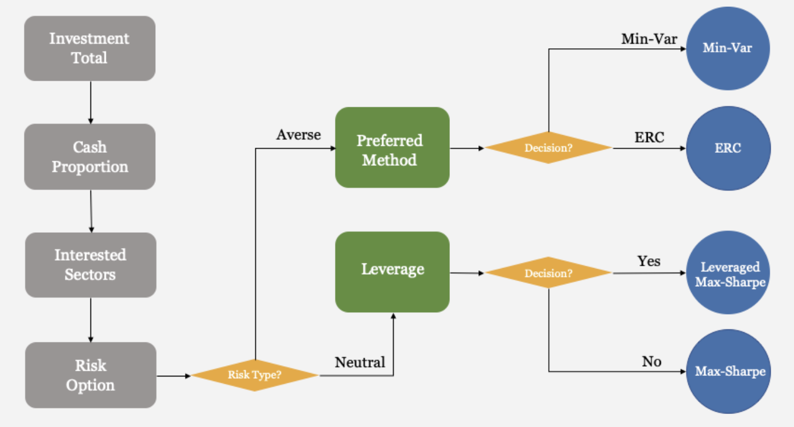

The first 3 questions are mandatory and do not branch. They ask about the investment capacity, cash preference and interested sectors in the market. The later questions are explained as below:

***Risk Appetite:***

Risk appetite is defined as the type and amount of risk that the investor is willing to take with the view of achieving their strategic objectives. There are two levels of risk tolerance in the chatbot, risk-averse and risk-neutral; investors choose the type they think they belong to.

* Risk-averse:
  + Only tolerate low risk chooses to preserve capital
  + Wish to have a conservative investment that grows slowly but steadily over time.
* Risk-neutral: The risk-neutral investor
  + Ignore the potential downside risk
  + Look only at the potential gains
  + Prefer an aggressive investment strategy to gain high profit
* Choosing financial strategy based on the risk-averse investor’s preference
  + Prefer Min-Var: then using Minimum Variance Portfolio Strategy
  + Prefer ERC, then using Equal Risk Contributions Portfolio Strategy

***Leverage Chosen:***

Leverage is an investment strategy that uses borrowed capital to expand investment funding. In a simple word, leverage is using borrowing money to invest. The investors decide whether to leverage according to their risk tolerance.

* Effects of leverage:
  + The investor with less cash could increase the buying power
  + Increase the return from a successful investment
* Limitations of leverage:
  + Amplify the investor’s potential losses
  + More risk, may lose more money than the investors have available
* Choosing financial strategy based on the risk-neutral investor’s response
  + Yes: Leveraged Maximum Sharpe ratio Portfolio Strategy
  + No: Maximum Sharpe ratio Portfolio Strategy

The questions being implemented here are of course on the simple/short side that it might not fully explore the client’s preference/needs. But it should be enough for you to have a peak of the logic and what extent of autonomy and intelligence we are expecting to achieve.

**Part II: DEMO walk-through**

1. Chat User Interface and chatting

* The user interface looks like following (full demo video in the presentation)

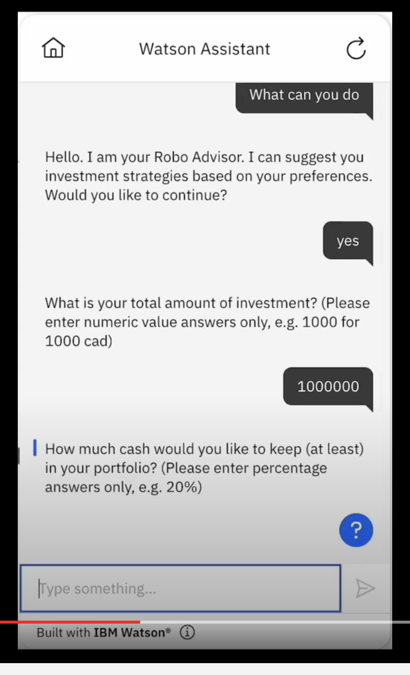

* The recepted answers are immediately communicated to the backend for processing.

1. Backend process

* Informations are being extracted from answer strings to determine customer preference:



* Optimization and following procedure are performed autonomously by the program

1. Deliverables

* Optimal portfolio weights will be outputted:



* So is the annual performance calculated by historical data:

Strategy "Equally Weighted Portfolio", CAGR = 15.45%

Strategy "Maximum Sharpe Ratio Portfolio", CAGR = 27.15%

* And a comparison to baseline strategy: equally weighted portfolio:

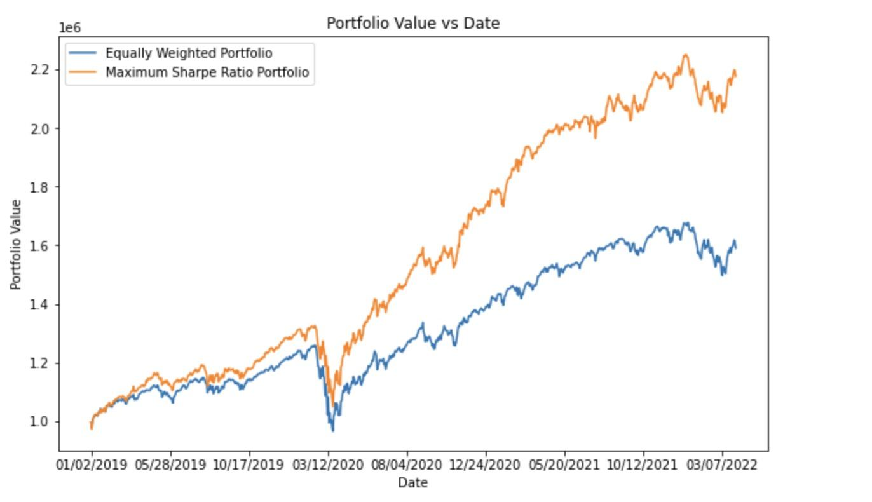

**Improvements for the future**

The version of the product we have now is still a prototype/work in progress. We believe in the potential of our products and much more features can be added given time. Following are some aspects that we might improve on first:

**Extensions to the chat-bot:**

1. ***Know you more*** – We keep the questions simple and compact for narrowing down the scope for presentation purposes. But there are obviously many more questions that can be asked to further explore the client preference. Things like how often they wish to rebalance their portfolio or
2. ***Delivery options –*** The client inputs are received/processed autonomously. But we didn’t do much for the delivery of results. There can be various ways to do so: We can send the result to the client in the chat box; We can email the result or we can just have them show up in their account history. We essentially want the whole thing to be more autonomous and free of human touch.
3. ***More features –*** The robot or the product as a whole can do more than just receiving preferences and compute weights. It can be more intelligent, things like giving macro advice to clients who want to double their investment in 5 years. Or the robot can make recommendations when the client doesn’t have a clear preference or have little knowledge about the ETF markets. The more features we add also enable us to charge higher prices for the premium services.

**Extensions to the backend:**

1. **Up-to-date Data –** We currently use pre-downloaded data for portfolio building and historical lookback. The process can be improved by connecting to financial modules to get up-to-date market prices on a daily basis.
2. **Simulation –** The clients obviously care more about the future than the past. Unfortunately, we can’t time travel to the future to get real portfolio performance. But we can get an estimate of possible performance by lots of simulations. This can be a nice add-on which better illustrates to the client what to expect in the future.
3. **Newer technology** – The methodologies we used are good but old-fashioned. And since machine learning has shined in the financial world for a while now, we figure it is fair to include some of the cutting-edge deep learning models for better performance.
4. **Metrics** – So far we only include annualized return and portfolio value to evaluate the portfolio. There can be more standards like standard deviation, max-drawdowns and so on. Adding more metrics will present to the client a more all-rounded view of the portofolio, attracting more experienced clients and building up the reputation.

**Conclusion**

In conclusion, we discussed the vacancy of autonomous financial tools that intend to guide people into the value investment world with reduced barriers. Our solution to this is a Robo-advisor that ideally will fill in the demand for general inquiry of investment related matters. The basic duties include portfolio building and exhibition of historical performance tailored by customer preference. It can be extended to provide more functionalities as well and therefore attract clients with more experience. We are optimistic about the future of our product and we certainly see the potential it carries to become bigger and smarter.

**References**

Chen, J. (2021). Risk Averse. Investopedia.Retrieved April 15, 2022, from <https://www.investopedia.com/terms/r/riskaverse.asp>

Freed, A. (2020). Analyzing and Improving a Watson Assistant Solution Part 3: Recipes for common analytic patterns. *IBM Data Science in Practice*. <https://medium.com/ibm-data-ai/analyzing-and-improving-a-watson-assistant-solution-part-3-recipes-for-common-analytic-patterns-1edb4b1f2ef2>

———.log_analytics. GitHub. <https://github.com/cognitive-catalyst/WA-Testing-Tool/tree/master/log_analytics>.

Porter, TJ. (2021). Trading Stocks with Leverage. *An Introduction to Day Trading.* Retrieved April 15, 2022, from <https://www.thebalance.com/trading-using-leverage-1031047>

Sette, M. (2022). Best Robo-Advisor. Investopedia. Retrieved April 15, 2022, from <https://www.investopedia.com/best-robo-advisors-4693125>